# Subsetting Pivot Tables

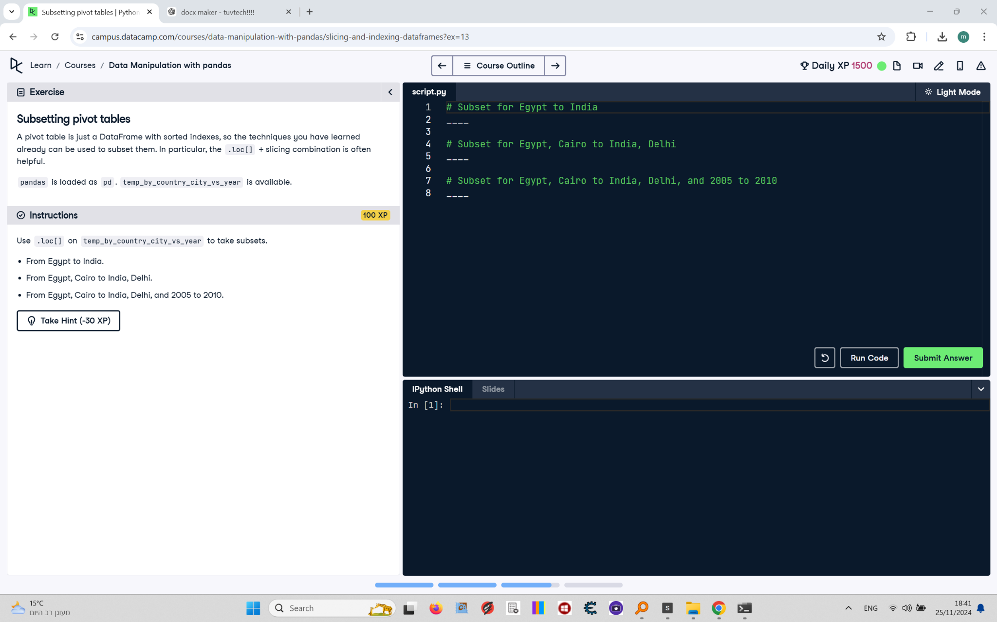

A pivot table is just a DataFrame with sorted indexes, so the techniques you have learned already can be used to subset them. In particular, the .loc[] + slicing combination is often helpful.  
  
pandas is loaded as pd. temp_by_country_city_vs_year is available.

## Final Answer

# Subset for Egypt to India  
print(temp_by_country_city_vs_year.loc["Egypt":"India"])  
  
# Subset for Egypt, Cairo to India, Delhi  
print(temp_by_country_city_vs_year.loc[("Egypt", "Cairo"):("India", "Delhi")])  
  
# Subset for Egypt, Cairo to India, Delhi, and 2005 to 2010  
print(temp_by_country_city_vs_year.loc[("Egypt", "Cairo"):("India", "Delhi"), 2005:2010])